**Expt No 01:**

**Create a simple cloud software application for Flight Reservation System using any Cloud Service Provider to demonstrate SaaS include the necessary fields such as one way, round trip, From, to, Departure, Departure, Travelers & Class, Fare Type, International and Domestic Flights etc.**

Date:21/02/2024

**Aim:**

Create a simple cloud software application for Flight Reservation System using any Cloud Service Provider to demonstrate SaaS include the necessary fields such as one way, round trip, From, to, Departure, Departure, Travelers & Class, Fare Type, International and Domestic Flights etc.

**STEP 01:**

Open a zoho web application and click a Create a New application and Create a New Component And select a Component Type as Form Type.

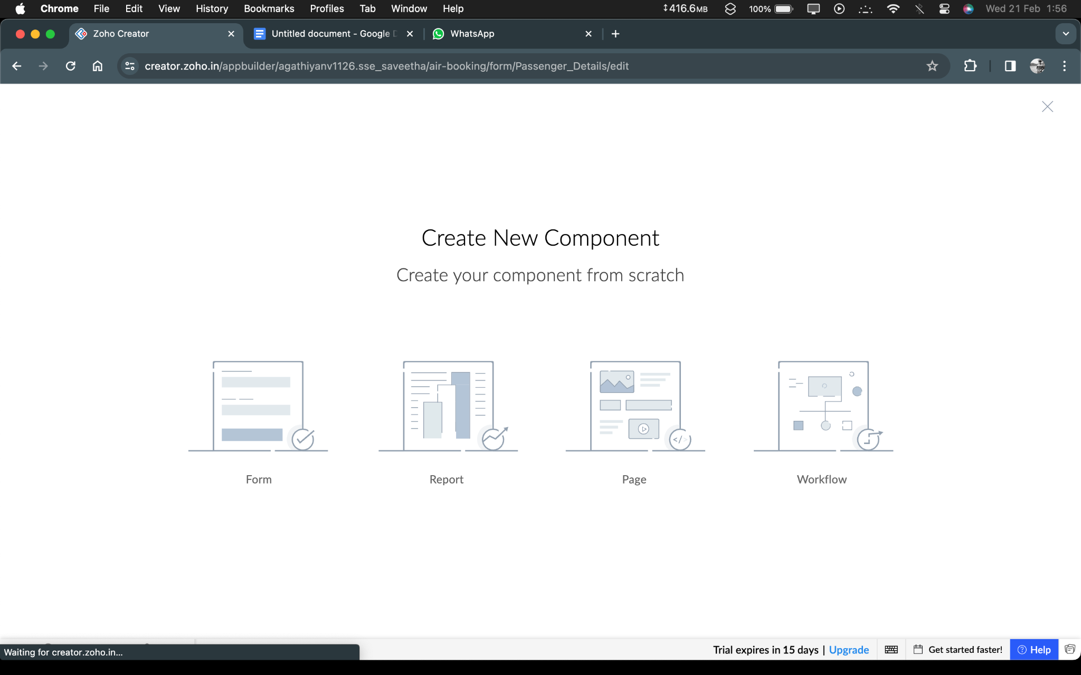

**STEP:02**

Start To a Create a Form from Scratch

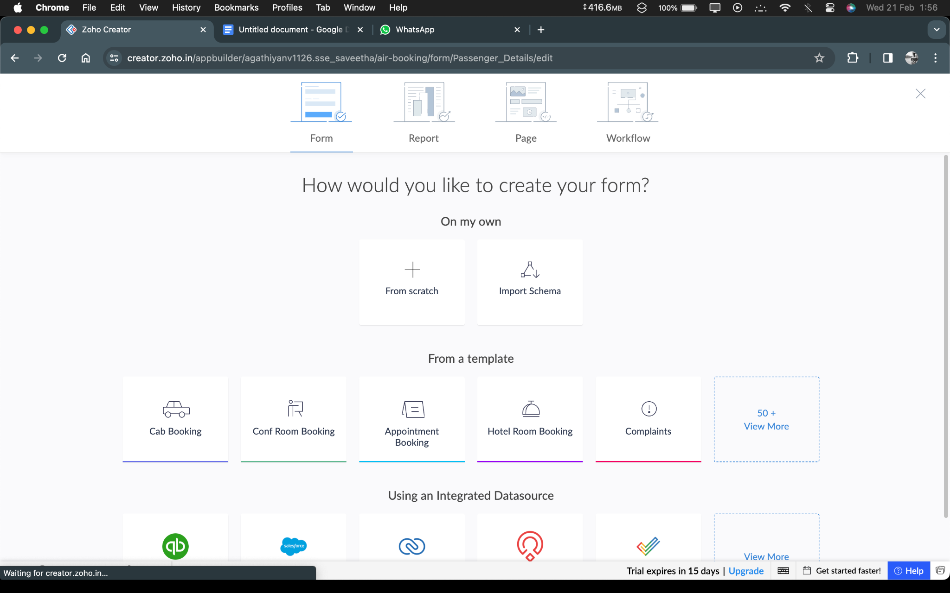

**STEP 03:**

To Give a Name For Your Form and click a Button Create From Scratch

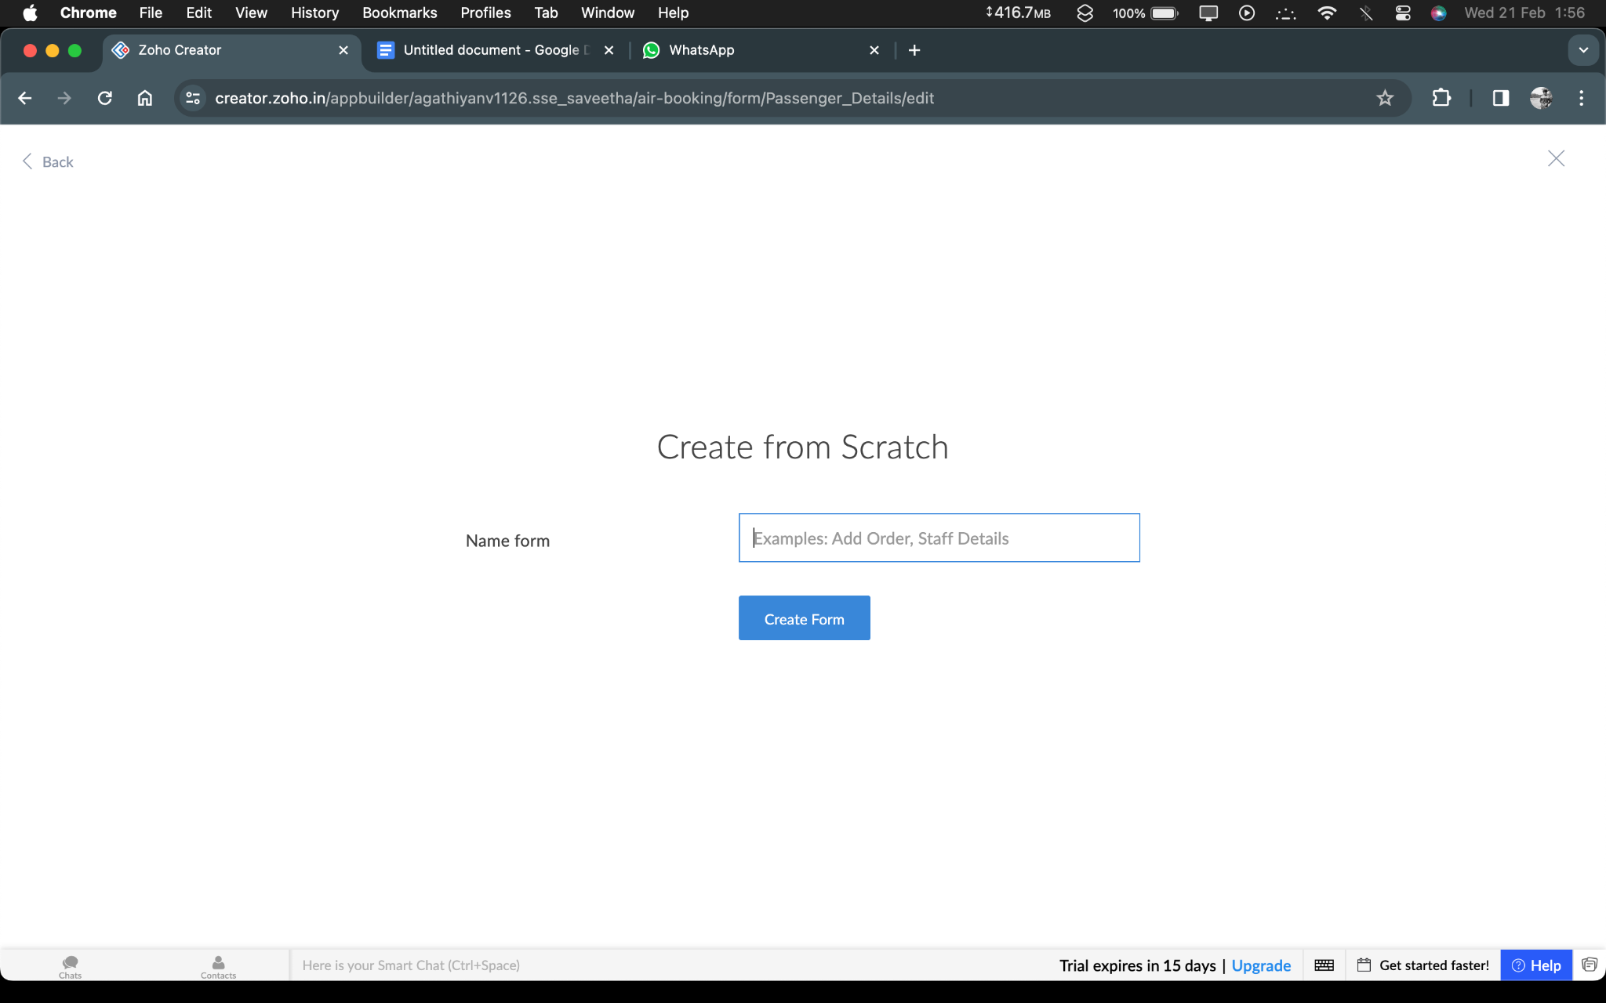

**STEP 04:**

Create a login Form and Edit your form

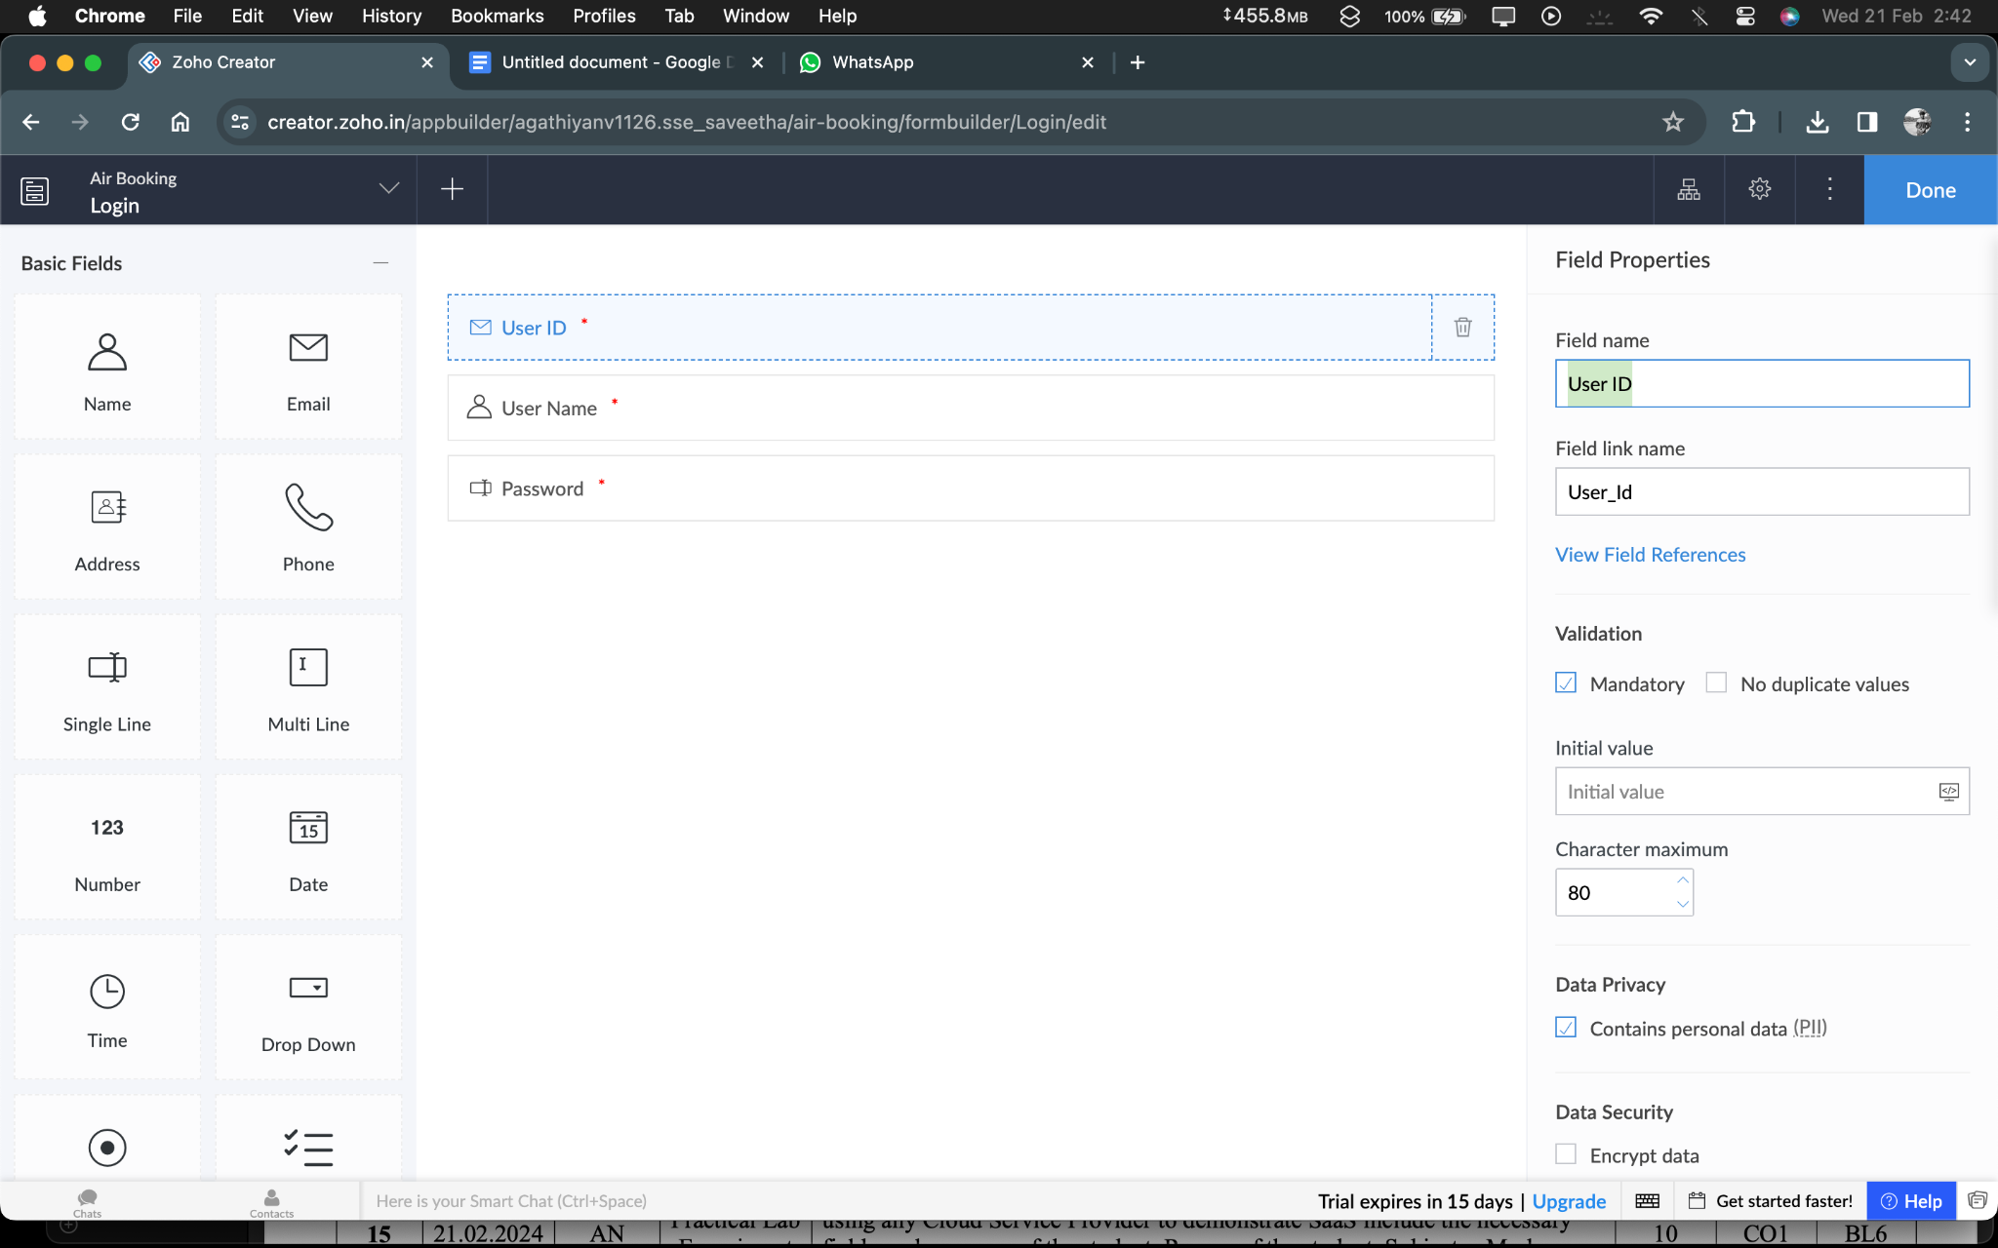

**STEP 05:**

After Finish the Edit Process click Done And then Open the View page.

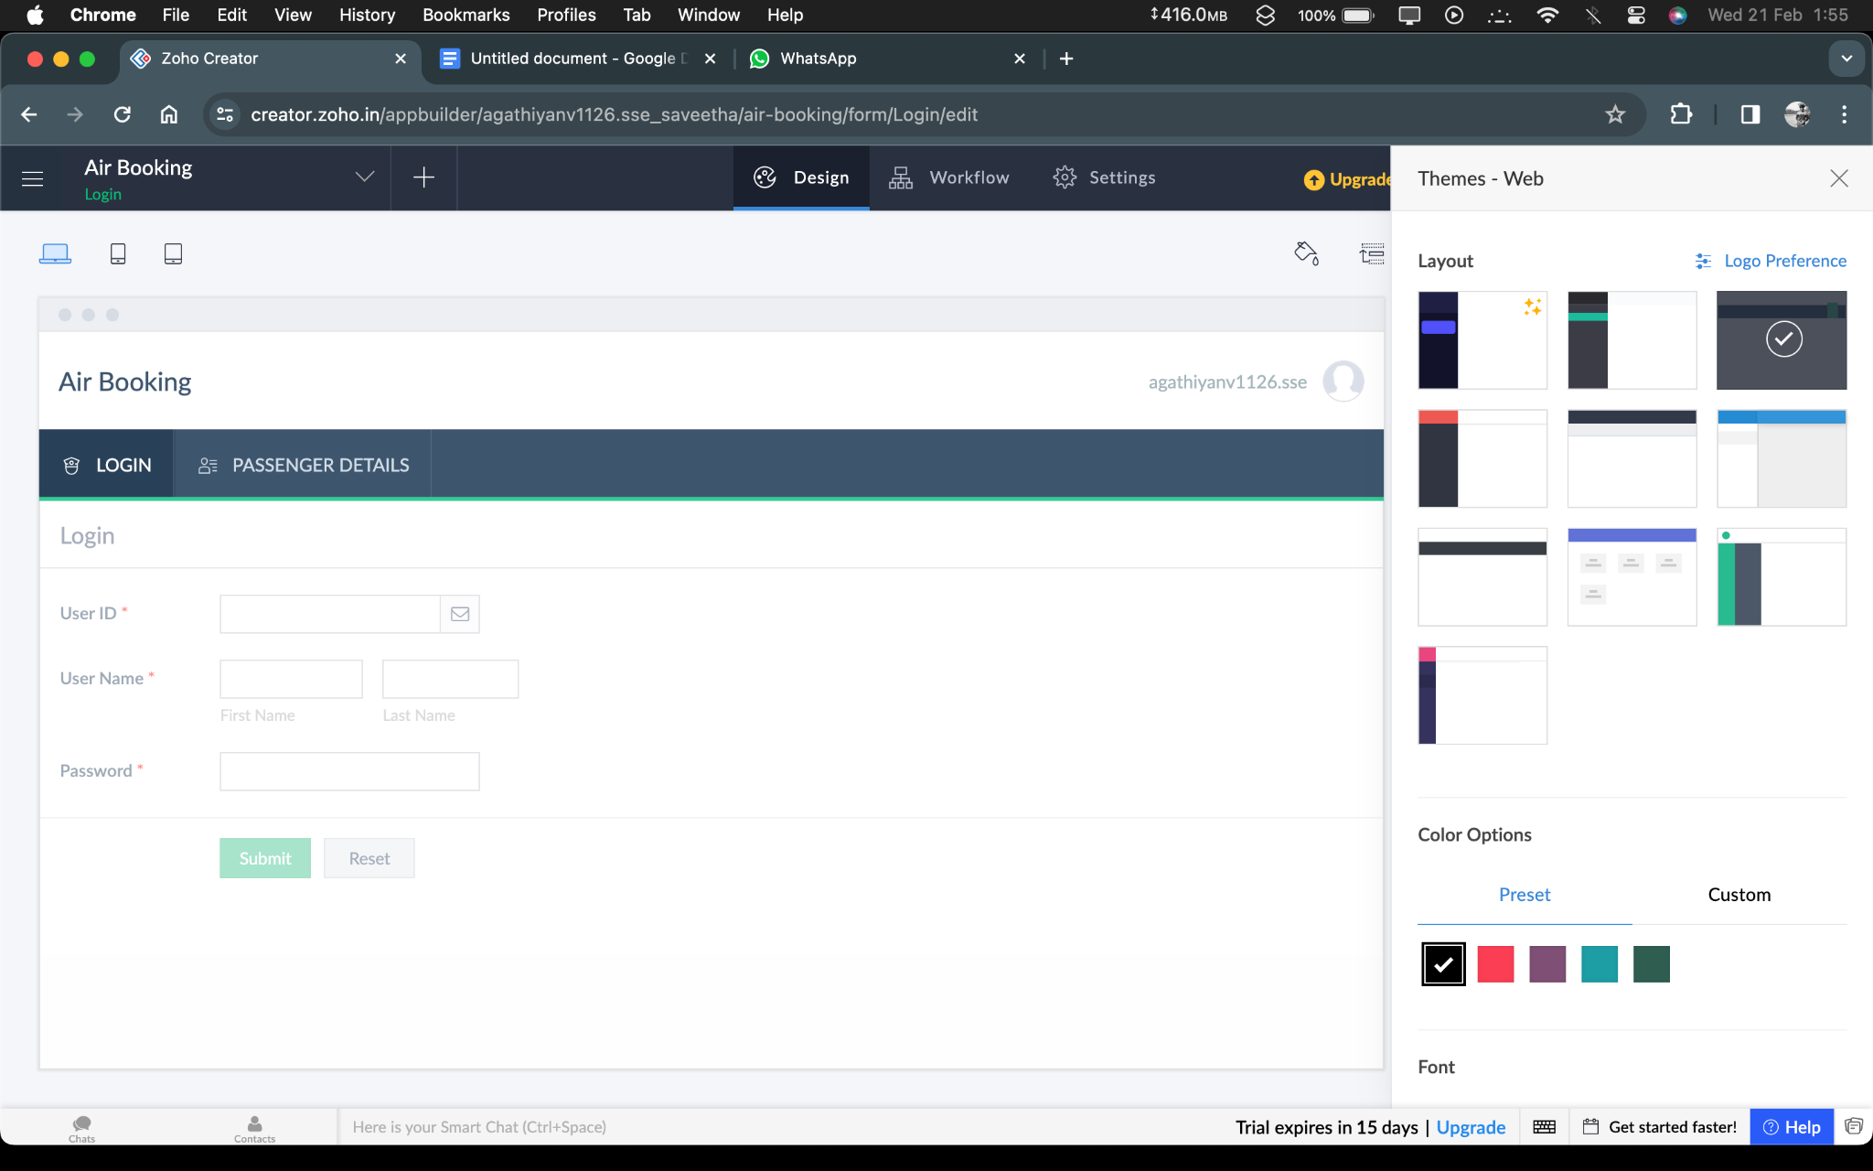

**STEP 06:**

After Finishing that Create another form for your application by clicking a Add icon and again create From scratch.



**STEP 07:**

Again Give a Name For Your Form and click a Button Create From Scratch



**STEP 08:**

Create a Passenger Detail Form for your Application and Edit your form.

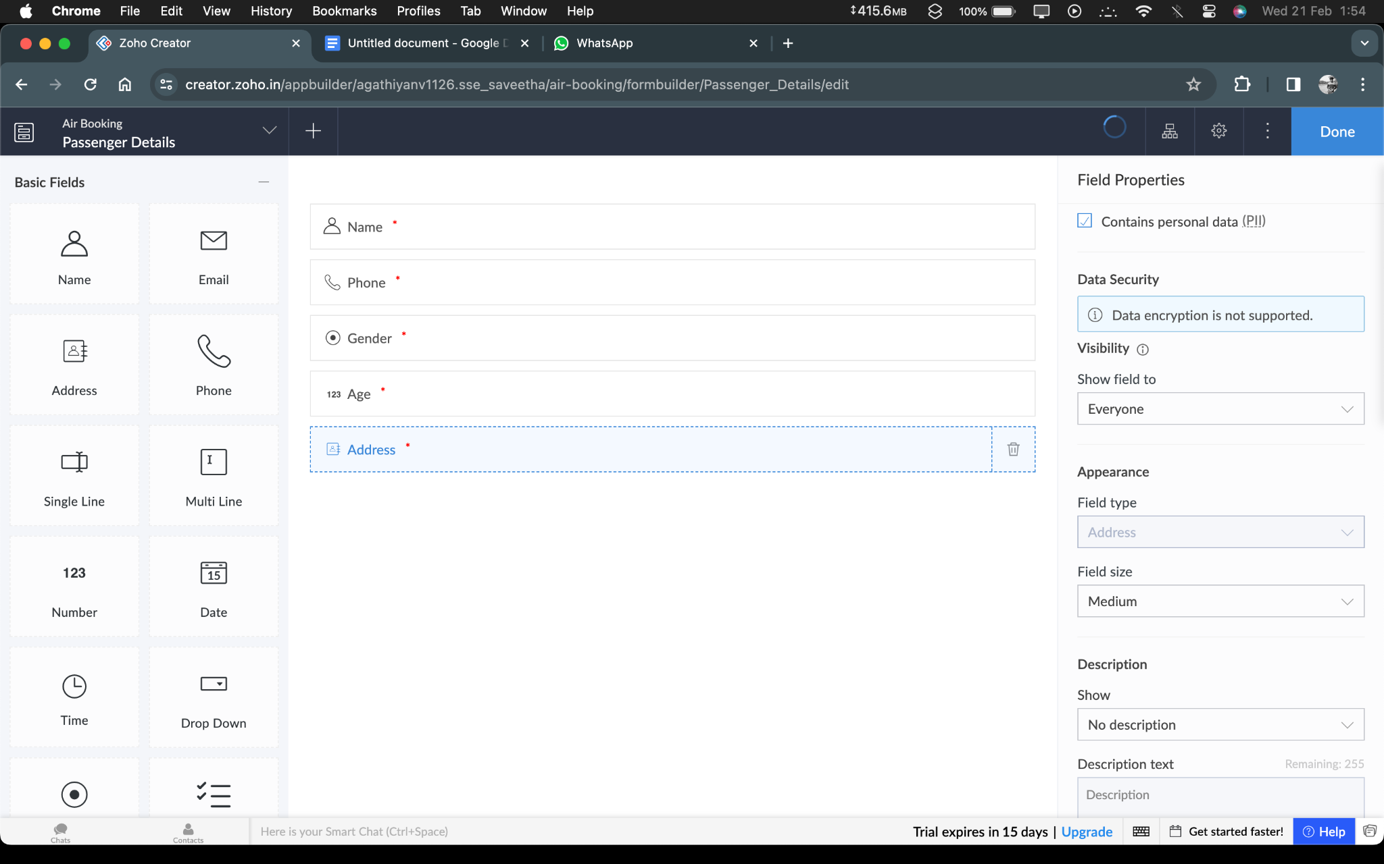

**STEP 09:**

After Finish the Edit Process click Done And then Open the View page.

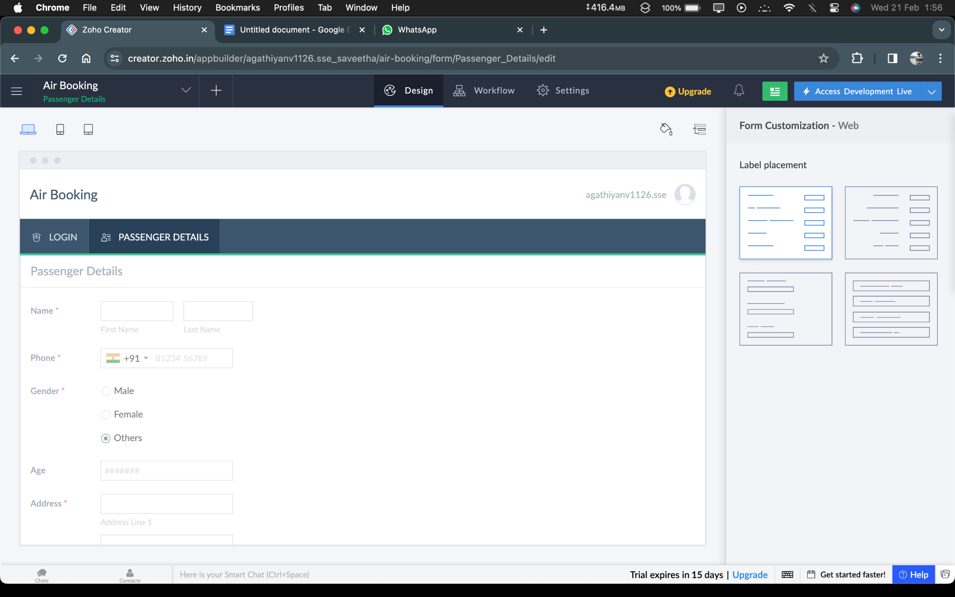

**STEP 10:**

After Finishing that Create another form for your application by clicking a Add icon and again create From scratch.



**STEP 11:**

Again Give a Name For Your Form and click a Button Create From Scratch.



**STEP 12:**

Create a Booking Form for your Application and Edit your form.

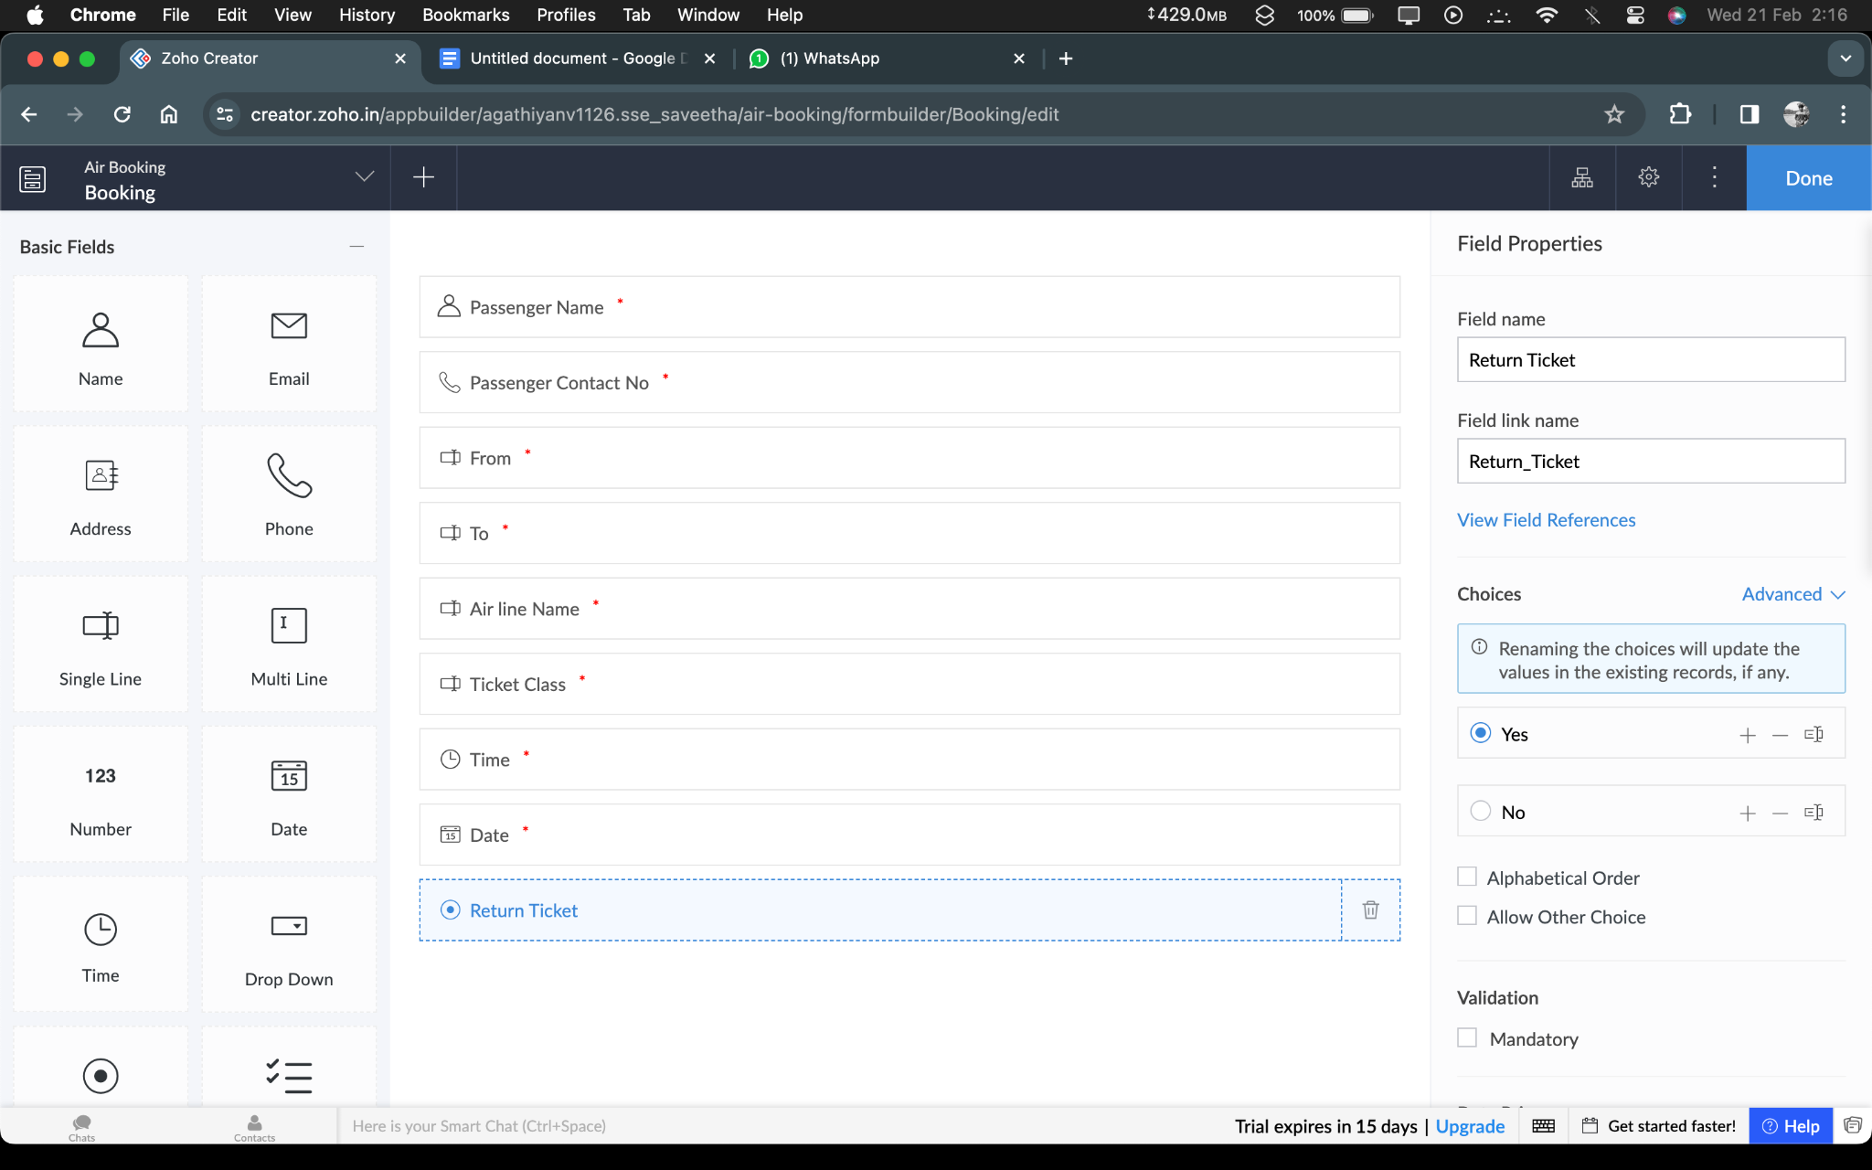

**STEP 13:**

After Finish the Edit Process click Done And then Open the View page.

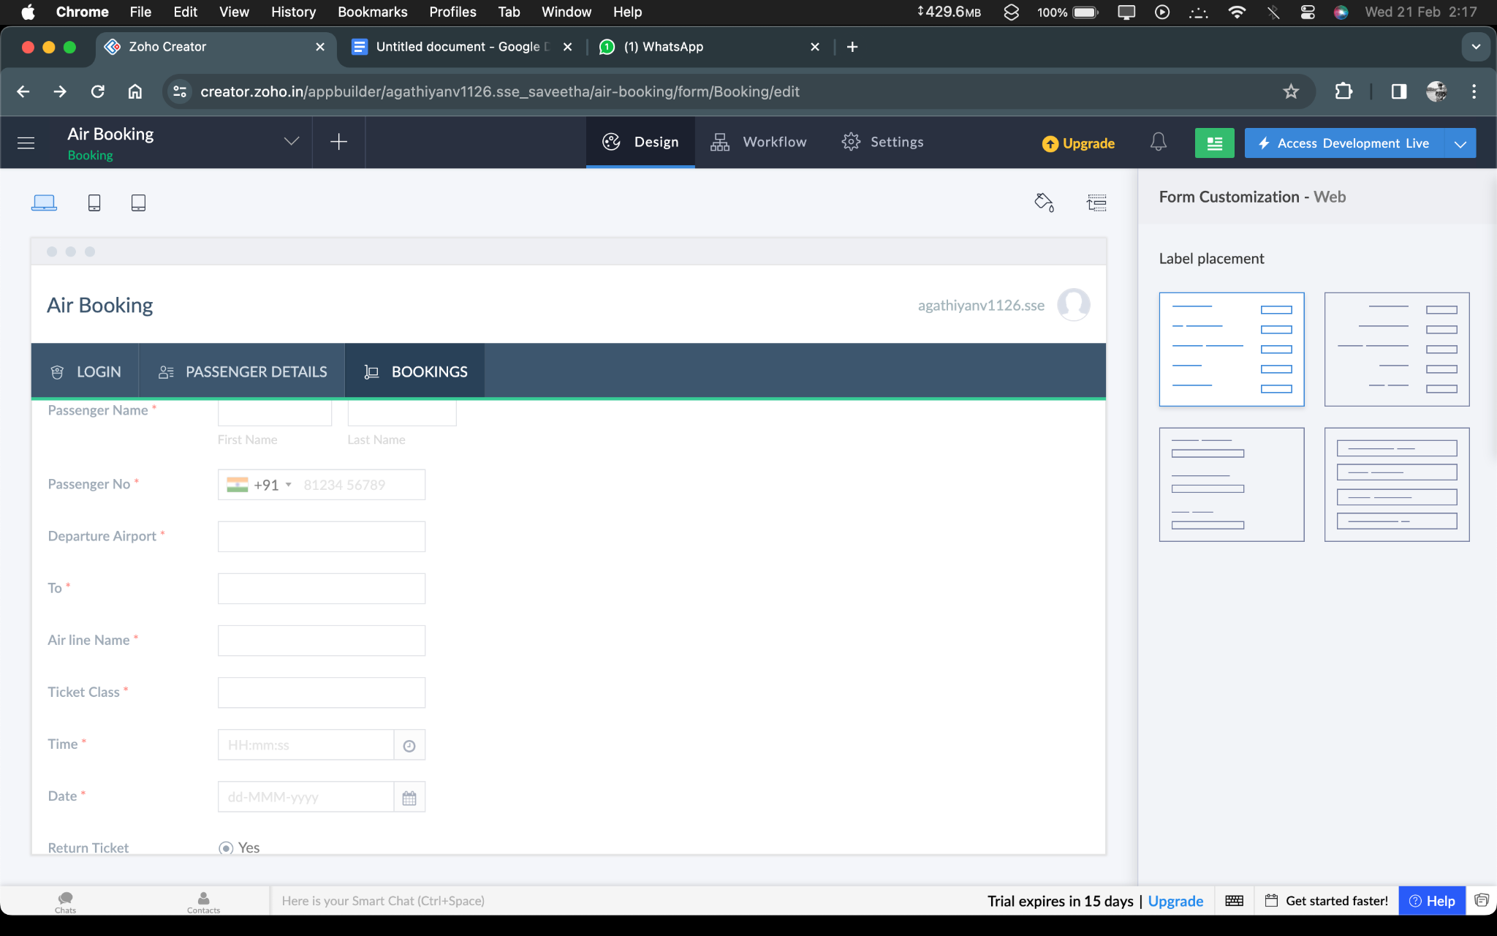

**STEP 14:**

After Finishing that Create another form for your application by clicking a Add icon and again create From scratch.



**STEP 15:**

Again Give a Name For Your Form and click a Button Create From Scratch.



**STEP 16:**

Create a Confirmation Payment Form for your Application and Edit your form.

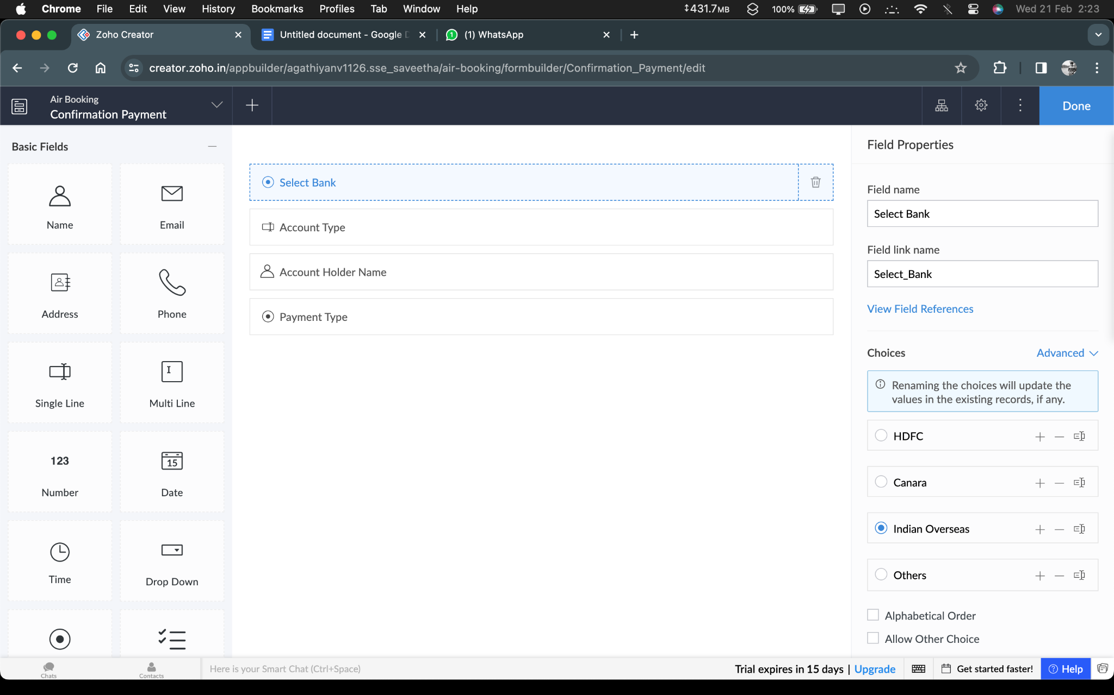

**STEP 17:**

After Finish the Edit Process click Done And then Open the View page.

